MEETING in MARSEILLE

Introduction welcome

Hello and welcome

Marseille is a city located in Provence in the south of France, capital of the Région-Provence Alpes -Côte d’azur and prefecture of the department of Bouches du rhône.
The mayor of Marseille is Jean Claude Gaudin.
The town has 16 administratives subdivisions.
In 2007, Marseille had 852 395 habitants.
Marseille is the second urban city in France behind Paris.
Marseille is cosmopolitain city because there are many people of all origins: north African,Comorian….
We have a culinary specialty: the “bouillabaisse” made with fish and crustaceans and most tourists come.
To baste this specialty in restaurants of Marseille. These restaurants are more particulary around the old port.
We have three representative symbole of an city but the most important is iron shield with a blue cross.
- 
Blason de Marseille
- Armoiries de Marseille au XIVe siècle 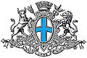
- 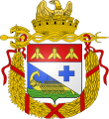Armoiries de Marseille sous le Ier Empire (1811-1814)
Marseille at the beginningMarseille is the oldest city in France, founded around 600 years before Christ by greek sailoss from Phocea in Asia minor,il was called Massalia.Today it retains a legend wade by ancient author Justin. Accoding to Justin,Marseille was occupied by a ligurian tribe. When the greeks arrived, the chief of the tribe organised a meal when her daughter. Gyptis had choose her husband.The greeks were inuted and the young Chief was chosen Protis.During Roman times, massalia was an important seapent in the south of this place of Roman empire, called “LA GAULE”
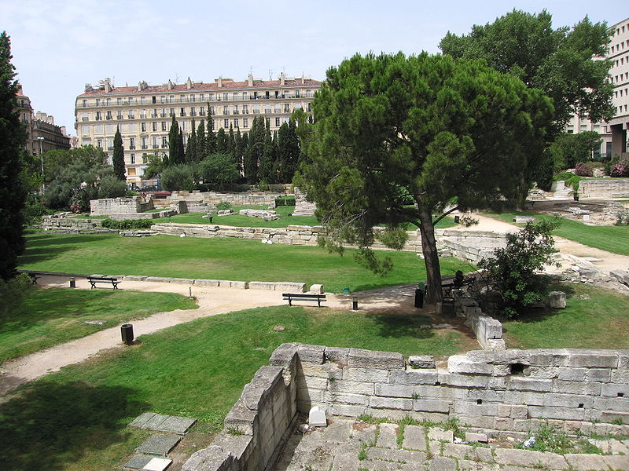

ABBEY OF ST VICTOR The Abbey st Victor was founded by Jean Cassien in the Vème century. It’s called Saint Victor because it was built on ancient cemetery of Marseille, including St Victor’s tomb. Victor was tormented during roman times on II century.The abbey was very important between 950 and 1150. Actually, it’s not a abbey since XIX ème century but a church where we can see a lot of relics and specially those of st Victor
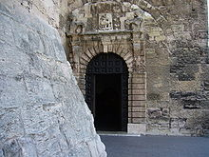
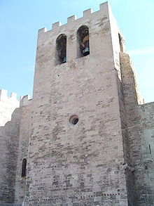

La Vieille charité
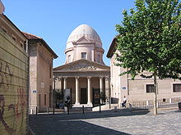
« La Vieille Charité « (the Old Charity) was built on XVIIème century by the architect Pierre Puget, with baroc style. This monument is situated in the oldest district of Marseille, called “le Panier”This place used as work homes for the beggars because , during XVII th and XVIIIth centuries, the repression of beggars was contucted with great brutality in France. Today, it is a museum containing antiquities

Notre Dame de la Garde
Notre Dame de La Garde also called here « the good mother » is basillica. She is situated on a limestone peak 149.meters in height. Built in XIX th by the architect Henri Esperandieu in the e neo Byzantine style the basilica was consecrated on and dedicated on june 5th , 1864.
In Marseilles, Notre Dame de la Garde is traditionally regarded by the population as the guardian and the protectress of the city.

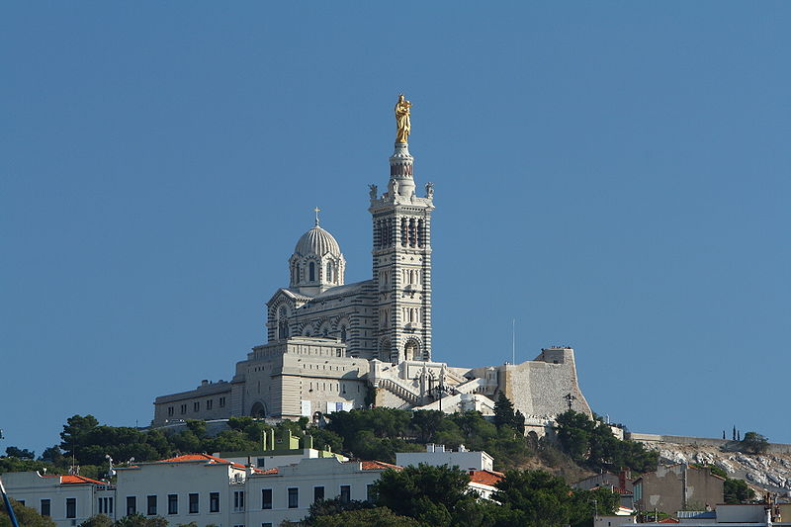

Le Palais Longchamp

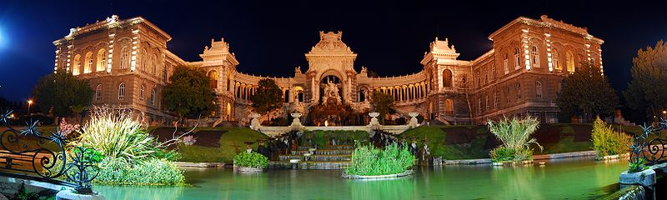
The Palais longchamps was created to celebrate the construction of the Canal of Marseille, which was built to bring water from the Durance by the architect Henry Esperandieu, the monument was centered on the structure and elaborate fontain known as the water castle of Marseille. It was inaugurated in august 1869

Marseille, gate way to the Colonies (XIXth –XXth )
Marseille is known as the gates way to the east, to wards African and Asian colonies.
Town was the port of French colonial world.
This past is visible in all the town, through statues representing colonies:
Exemple: Statues of the St Charles station’s stairs

